August 2004

OSCE Station1

Back Examination

Back pain and sciatica: GP Registrar Briefing Sheet

The patient is a 28 year old dentist. (S)he is complaining of back pain and what (s)he believes may be sciatica.

The history is that this spring (s)he has been doing lots of work in her/his new garden – including creating a pond. With each day of gardening (s)he has found that her/his back has ached increasingly in the evening.

Last weekend after going out on her/his bicycle (s)he developed very unpleasant pain in her/his left posterior thigh.

When asked (s)he will say that her/his pain is increased by sitting and (s)he will be reluctant to sit when invited into the consulting room. “I’d rather stand” (S)he will say that driving and sitting on the toilet are excruciatingly painful. (S)he is reasonably comfortable standing and lying down – the latter preferably on her/his front.

(S)he also has some pins and needles on the lateral border of his left foot.

The task is to undertake an examination of the patient’s lumbar spine.

August 2004

OSCE Station 1

Back Examination

BACK PAIN AND SCIATICA: PATIENT BRIEFING

You are a 28 year old dentist complaining of back pain and what you believe may be sciatica.

The history is that this spring you have been doing lots of work in your new garden – including creating a pond. With each day of gardening you found that your back has ached increasingly in the evening.

Last weekend after going out on your bicycle you developed very unpleasant pain in your left posterior thigh.

When asked you will say that his pain is increased by sitting and you are reluctant to sit when invited into the consulting room. “I’d rather stand” You will say that driving and sitting on the toilet have been excruciatingly painful. You are reasonably comfortable standing and lying down – the latter preferably on your front.

You also have some pins and needles on the lateral border of the left foot.

The doctor’s task is to undertake an examination of your lumbar spine.

The examination findings are left straight leg raising limited to approximately 50cm by pain in the thigh and some reduced sensation on the lateral border of the left foot.
If his back is palpated he will complain of soreness on pressure over L5.
His spinal movements are only slightly restricted in forward flexion – being able to reach mid shin with his finger tips – again he will indicate some soreness around L5 and L posterior thigh pain
A slump test if performed will be excruciatingly painful on the left and he will display some reluctance to perform the test.

You may need to practice with the assessor.

August 2004 ASSESSORS INSTRUCTION SHEET

OSCE Station 1

BACK EXAMINATION

You will need a volunteer patient who is prepared to have their lumbar spine examined: see handout.

There is no need for the GP Registrar to take a history. The GP Registrar is asked to undertake an examination of the lumbar spine. You may need to brief the patient to demonstrate the relevant findings. It is not appropriate to allow the GP Registrar to undertake a test for saddle anaesthesia for reasons of dignity.

Equipment required:

Examination Couch, tape measure, pin or monofilament for testing sensation, seat for slump test, tendon hammer.

The handout is also the assessment and feedback sheet for the GP Registrar

Checklist for marking

Observation
Posture Yes/no/partial
General comment on mobility Yes/no/partial
Visible deformity Yes/no/partial

Active movement
Flexion Yes/no/partial
Extension Yes/no/partial
Side flexion Yes/no/partial
Rotation Yes/no/partial
Slump test Yes/no/partial
SLR Yes/no/partial
Passive knee bend Yes/no/partial

Palpation

Interaction with the patient
Considerate of symptoms Yes/no/partial
Confidence Yes/no/partial
Explanation of technique and findings Yes/no/partial

Any comments?
Handout

Examination of the Lumbar Spine

If the patient complains of leg symptoms refer to the dermatome section to give a reasonable assumption at which level the lesion is, i.e. lateral calf numbness/P+N/pain=L5 nerve root. (However remember a high lesion can affect lower nerve roots!).

Subjective Examination
The lumbar spine normally gives pain during prolonged sitting, lifting and stooping. Generally pain upon walking tends to originate from the hip, spinal stenosis or circulatory disorders. For objective markers use functional levels to assess improvement i.e., time to dress, sit etc without pain.

Examination undertaken satisfactorily: Yes/No/incomplete

Objective Examination
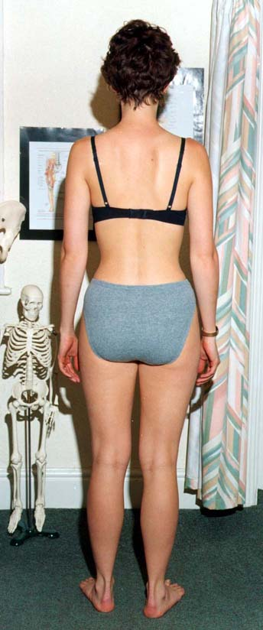
Leg length discrepancies are best judged
in standing – use different sized heel raises/arch
supports to correct inequality.

Examination undertaken satisfactorily: Yes/No/incomplete

Check
Correctable scoliosis, increased thoracic
kyphosis tone/bulk loss and general posture.

Examination undertaken satisfactorily: Yes/No/incomplete

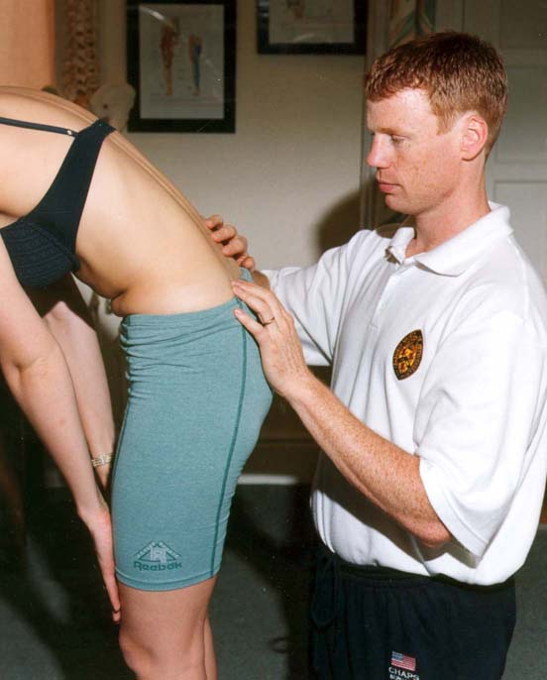

Flexion
Getting the patient to touch their toes will measure hip/neural flexibility not lumbar movement. For a more accurate measurement palpate individual segmental movement.

Examination undertaken satisfactorily: Yes/No/incomplete

Check

Correct pelvic tilting rhythm

Examination undertaken satisfactorily: Yes/No/incomplete
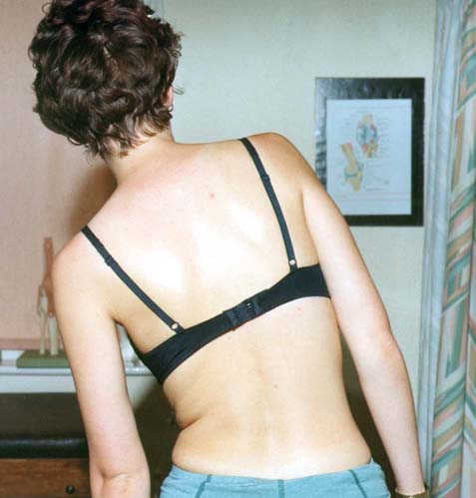

Side Flexion

Measure hand to knee distance

Examination undertaken satisfactorily: Yes/No/incomplete

Check
Quality of each segmental movement

Examination undertaken satisfactorily: Yes/No/incomplete

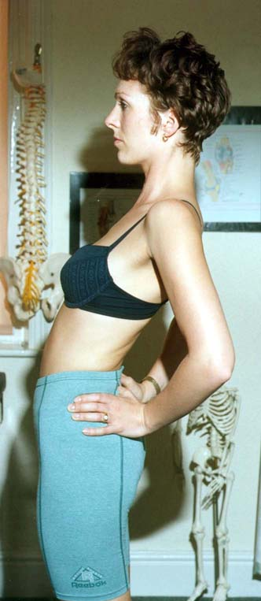
Extension
Often restricted but sometimes relieves symptoms.

Examination undertaken satisfactorily: Yes/No/incomplete

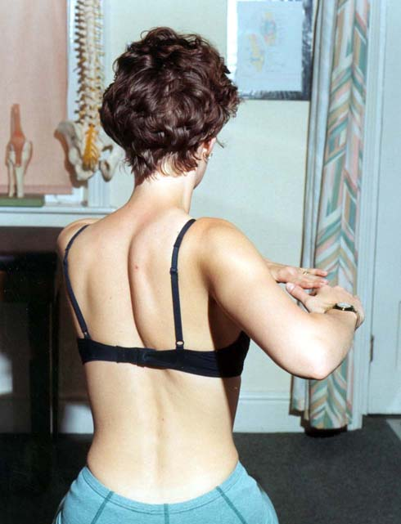

Rotation
Best measured in sitting to eliminate Leg/Hip rotation.

Examination undertaken satisfactorily: Yes/No/incomplete

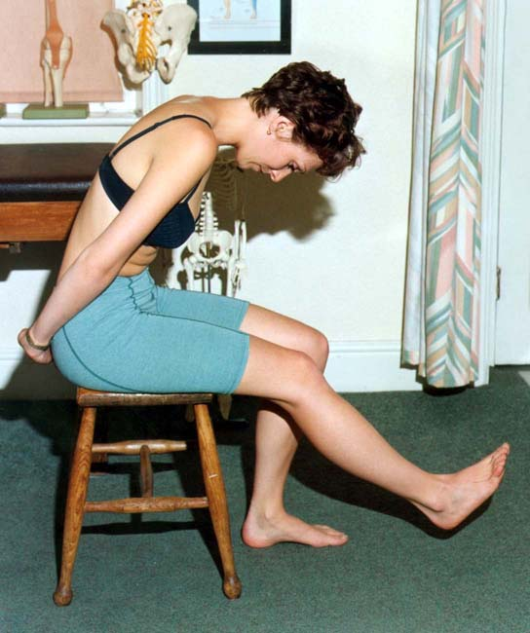
Check
Asymmetry
Examination undertaken satisfactorily: Yes/No/incomplete

Slump Test
This is quite an aggressive test to check neural length. Problems driving are often reproduced.

Examination undertaken satisfactorily: Yes/No/incomplete

Check
Good to affected. Add in ankle dorsiflexion and knee extension slowly. Compare this test to SLR i.e.. If slump test negative but SLR 30 deg positive!!

Examination undertaken satisfactorily: Yes/No/incomplete

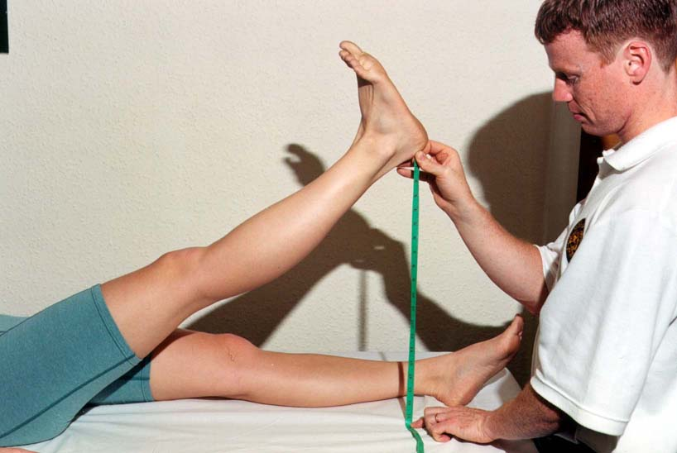

SLR

Measure heel to plinth with knee locked in extension and ankle plantargrade.

Examination undertaken satisfactorily: Yes/No/incomplete

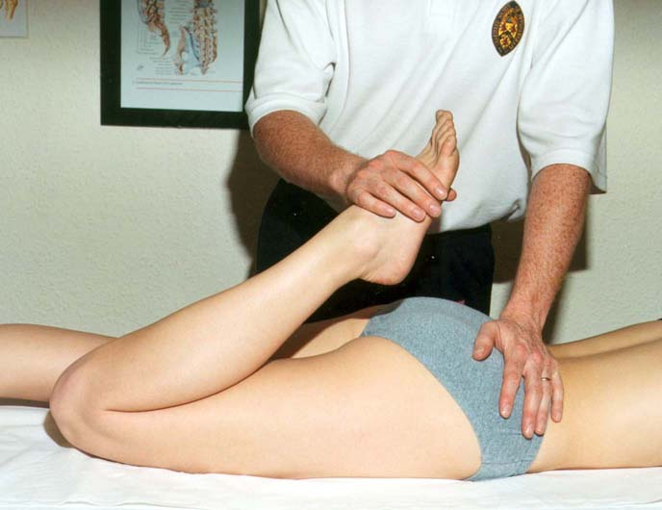
Passive Knee Bend
To check femoral nerve length. Add in foot movements to reproduce the patient’s pain.

Examination undertaken satisfactorily: Yes/No/incomplete

Finally, palpate to pin point the local lesion start lightly

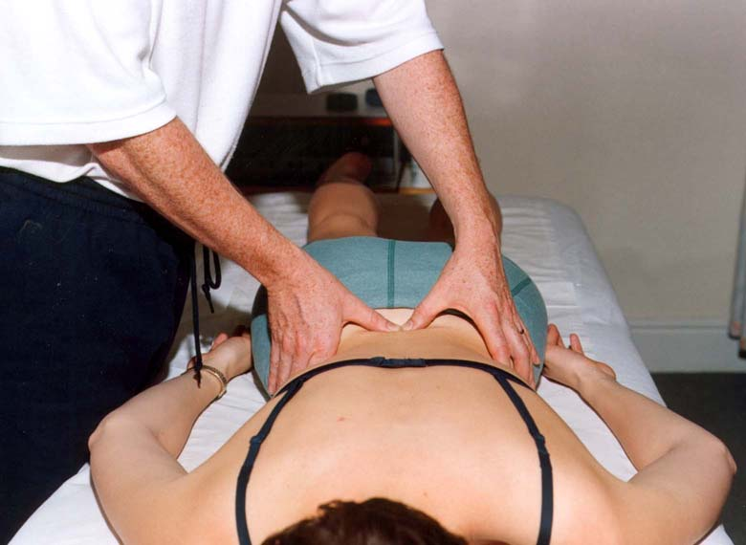
Examination undertaken satisfactorily: Yes/No/incomplete

